The following resources are for the book study of Yay! I'm A Supervisor!

Watch The Vlog Videos on the book: http://bit.ly/yaystudy
Subscribe to The YouTube Channel: http://bit.ly/jodytubesub
Audible: http://bit.ly/yayimasupervisor
iTunes: http://apple.co/2vwMl8m

Chapter 1 - Management Versus Leadership
  - When have you experienced frustration with not having the right tools to do a job? What difference did it or does it make to have the right tools in place?
  - What is your definition of management?
  - What is your definition of leadership?
  - Are management and leadership the same or different? How?
  - What tools/skills do you believe are the most important for a manager to have?​

Chapter 2 - Values-Based Diversity
  - The five generations mentioned are the Traditionalists, Baby Boomers, Generation Xers, Millennials, and Generation Z. Which generation do you most closely identify with and why (regardless of when you were born)?
  - Massey outlined three stages of psychological development. Imprinting (0-6), Modeling (7-13), and Socialization (14-22/26). What were one or two moments in your life at any of these stages that helped to shape the way that you view work?
  - What are your thoughts on why younger generations behave differently at work than older generations?
  - If you could go back and give 10-year-old you some advice related to success in life, what would it be?
​
  - Who is someone in your life that you have looked up to? What was it about them that inspired you?

Chapter 3 - Motivation
  - Why did you show up to work?
  - Maslow indicated that people who intentionally become less than they are capable of being would be unhappy for the rest of their lives. What have intentionally not done as well as you could? Why do you think that is?
  - Dan Pink indicated that people are driven by autonomy, mastery, and purpose. What are some ways that you could create that kind of an environment for your teams?
  - Maslow's Hierarchy of needs indicates that each level of need must be satisfied before one can focus on the next level. Do you agree or disagree? Why?
  - Herzberg's 2-Factor Theory focuses on satisfiers (internal motivators) and dissatisfiers (external motivators). He indicates that motivation to perform is driven only by internal factors. When the external factors are not taken care of, they decrease motivation. Think about a time when you were particularly engaged or disengaged at work. What was going on and why do you think that you felt that way?

Chapter 4 - Communication
  - How do you think that intrapersonal communication (self-talk) impacts the manner in which an employee works?
  - There are several parts to communication. There is the sender, receiver, message, and medium. Which of these is the most complicated to figure out? Why?
  - In the AWARE model, which of the components is the toughest for you, the easiest for you, and why?
Accept, Wait, Anticipate, Respond, Engage
  - Which of the five types of communication are you the most comfortable and confident with?
Intrapersonal, Interpersonal, Small Group, Group or Public Speaking, Mass Communication (includes social media)
  - Nonverbal communication accounts for 93% of how we interpret messages from others. This includes the way a person dresses, their facial expressions, their body language, their tone of voice, etc. What non-verbal factors are different now than they were 20 years ago? And, which ones irritate you?

Chapter 5 - Coaching
  - Think about a coach that you had during your life that was good for you. What was it about them that made you want to perform for them?
  - In the SOFT Model of coaching, The S stands for Set Expectations. When was a time that you wanted to succeed for a person but did not know what they really expected from you? How did that impact your image of them as a leader?
  - There are four types of authority at work. What do you see as the benefits and drawbacks of each type of authority?
T – Title
E – Expertise
R – Relationship
C – Contract
  - The F from the SOFT model is Follow the process. Discuss how the second component of the process can help to establish accountability in the mind of an employee.
  - The T in the SOFT model is about Teaching your team to self-lead. What are some ways that you can create ownership for an employee's future in the mind of that employee? In other words, how do you get your employees to own their actions and their choices moving forward?

Chapter 6 - Conflict Resolution
  - Conflict is a natural and normal part of our everyday lives. When you think about conflict, what are the negatives that come to mind?
  - In a conflict, there is either a collision of needs or a collision of values. What is the difference between the two and which is more difficult to solve? Why?
  - There are four fundamental issues in conflict. Which do you deal with most often? Why do you think that is?
Facts (Pragmatic truth - How we label truth in our mind)
Goals (When my goals are in conflict with someone else's goals)
Methods (The process of accomplishing goals)
Values (Worrying about our image, our view of the world, etc)
  - B-FIRM is the model for addressing conflict. What do the letters stand for and why is it important to avoid using judgmental labels for behaviors?
  - There are five phases to conflict. Many people will avoid conflict until it truly becomes open conflict. Talk about a time that you have seen people avoid dealing with conflict too long. What happened? What was the result?
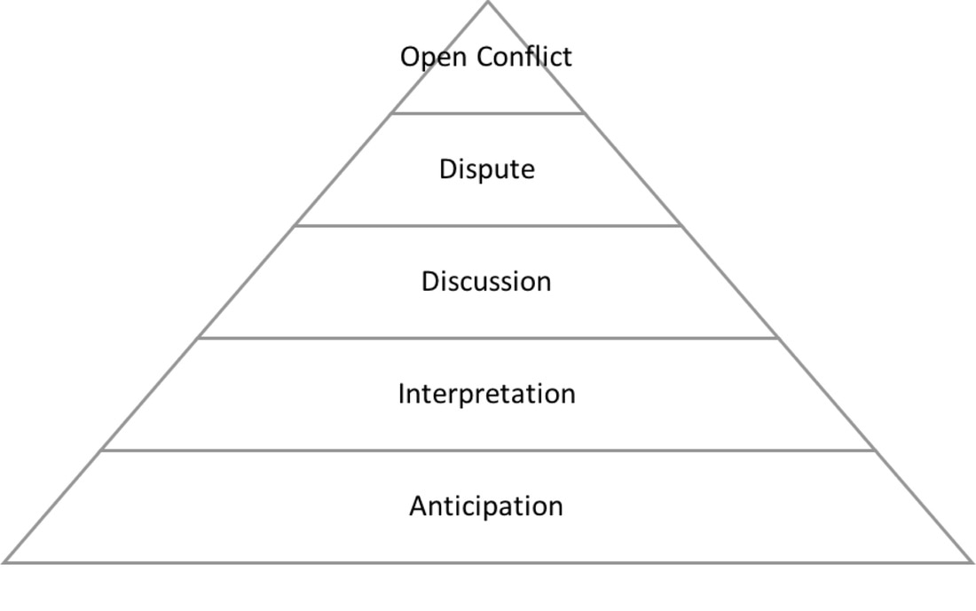

Chapter 7 - Corrective Counseling

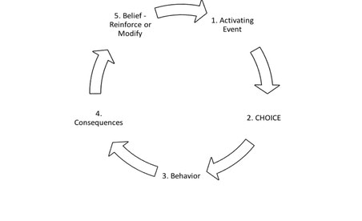
  - There are three main reasons that an employee will fail to perform at work. Which of these do you deal with the most often? What has your experience been with them?
Lack of knowledge
Lack of ability
Lack of engagement
  - The three components of a work habit are queue, response, and reward. Which part do you have the greatest influence over? How do you influence it?
  - We operate in a belief loop. In order to change a person's behaviors, you have to get them to own their choice both from the past and from the future. Discuss the components of the belief look and how your beliefs about work shape your behaviors.
  - The Greek Philosopher, Epictetus, observed that people are not disturbed by things that happen but by the view they take of things that happen. Talk about a time when your view and an employee's view of what happened was different. How did you handle it?
  - What are the three questions that you have to ask in order to create internal ownership of what happened as well as to establish the employee's ownership of what their actions will be next time?
​

Chapter 8 - Goal Setting
  - The number 1 killer of goal accomplishment is procrastination. What can you do in order to overcome or beat procrastination?
  - The T in the TARGET process is to think from the end to the beginning. Talk about a goal that you have and how you could outline the daily behaviors required to achieve the goal by the deadline.
  - It is important to give your goals emotions. What is one company goal that you could add positive emotion towards its attainment and negative emotion toward staying the same? How will you accomplish adding the positive and negative emotions?
  - The E in TARGET is Eyes Wide Open. What is necessary within your team for people to be completely honest about what is preventing a goal from happening? How can you track progress on a regular basis towards a corporate goal?
  - It is important to talk about your goal. Share a goal that you have related to accomplishing something at work. Talk about it confidently and establish that you will accomplish it by a certain date.

Chapter 9 - Problem Solving
  - Problem solving success is dependent on uncovering what the need is related to a problem and being able to fulfill that need. Pick a problem at work and identify what is missing or needed in order to not have to deal with the problem again.
  - The three basic responses to a problem are to blame, accept, or measure. Which of these approaches sets you on the path to resolving the problem? And, what is the challenge or weakness with the other two?
  - The two types of data that you will gather are qualitative and quantitative. What is the difference between the two? When was a time that you gathered data in each of those types of data?
  - In order to discover what the data is telling you, what are the four questions of data interpretation that must be answered?
  - What are the steps in SOLVE process? Choose a problem that you are facing at work and talk through each of the steps.
Chapter 10 - Group Decision Making
  - There are two sides to the coin when decisions are being made. You have what is going on outside of the person (the data) and what is going on inside of the person (self-talk). Talk about a time that someone had the facts and data but still went with what was in their head instead. How did it turn out?
  - What is mismanaged agreement as described in the Abilene Paradox? When have you seen something like that at work?
  - What can you do to prevent group think from happening in a meeting?
  - What are the nonverbal signals that people give off when the disagree, even if they don't speak up?
​
  - What are the steps in the THINK process that prevent group think?
​
  - Bonus Question... What are the four types of meetings? How can we keep our meetings focused and worthwhile?

Chapter 11 - High Performance Teams
  - What are the differences between a team and a group?
  - The C in CREATE is for Come together. What can you do with a new team or a new team member to create a more cohesive team and to get to know each other?
  - What do you do to discover an employee's strengths at work? What can you do to give them a chance to operate in those strengths?
  - What is a winning spirit to you? How do you build a winning spirit at work?
  - What are the components of the PERFORM model? Is there a step that is the most important to you? Why that one?​

Chapter 12 - Ethics, Values, Culture
  - There are four levels of ethics, represented by the acronym ALSO. What are those four levels? Which one do you relate to the best?
  - Are there any absolutes with ethics? If so, what are they?
  - What values are absolutes for you that you would not compromise on?
  - What are the values that are the most important for our organization to have?
  - What is the CULTURE model and how would you apply that to your organization?

Chapter 13 - Priority Management
  - What typically interrupts you during your work day? How do you deal with those distractions?
  - How can you be the boss of your technology?
  - What is the Pareto Principle and how have you applied it at work? How can you apply it in order to be more focused on what generates success for you?
  - What are the five or fewer most important things for you to do every day in order to be successful at your job?
  - There are five categories of things that you do during the day. What can you put into place in order to stay focused on what matters the most?
​1. Daily Habits of Success
2. Critical now
3. Critical, but not right now
4. Important to others
5. Not important to success

Chapter 14 - Next Steps
  - Discuss ways that you can find your next top performer.
  - Choose the next book that you will read and study. Find great ideas at: http://bit.ly/jodyholland
  - What are some ways that you can work with your team and make them feel that you are a part of the team, instead of above the team?
  - Develop your team's potential... What can you do in order to increase the potential of your team?
​
  - What was the most valuable lesson that you have learned in this book?
​Audible: http://bit.ly/yayimasupervisor
iTunes: http://apple.co/2vwMl8m

If you enjoyed the book, I would love for you to review it on Amazon and iTunes:
http://bit.ly/yayreview

